# Creating Windows and Linux Virtual Machines on Microsoft Azure

* A Windows 11 VM
* An Ubuntu Linux VM

## Open the Azure Portal

1. Go to [https://portal.azure.com](https://portal.azure.com/)
2. From the dashboard, click Virtual Machines or Create a resource

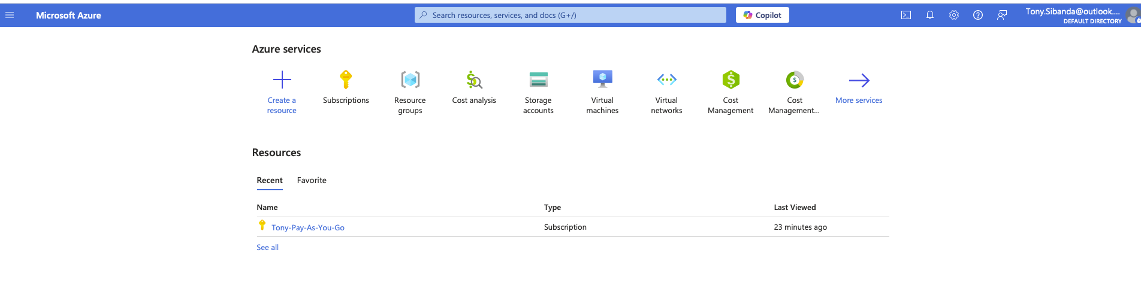

## Create a Resource Group

1. Click Resource groups in the left menu
2. Click + Create
3. Name the group RG-Network-Activities (any name that you want)
4. Set Region to (US) East US 2
5. Click Review + create, then click Create

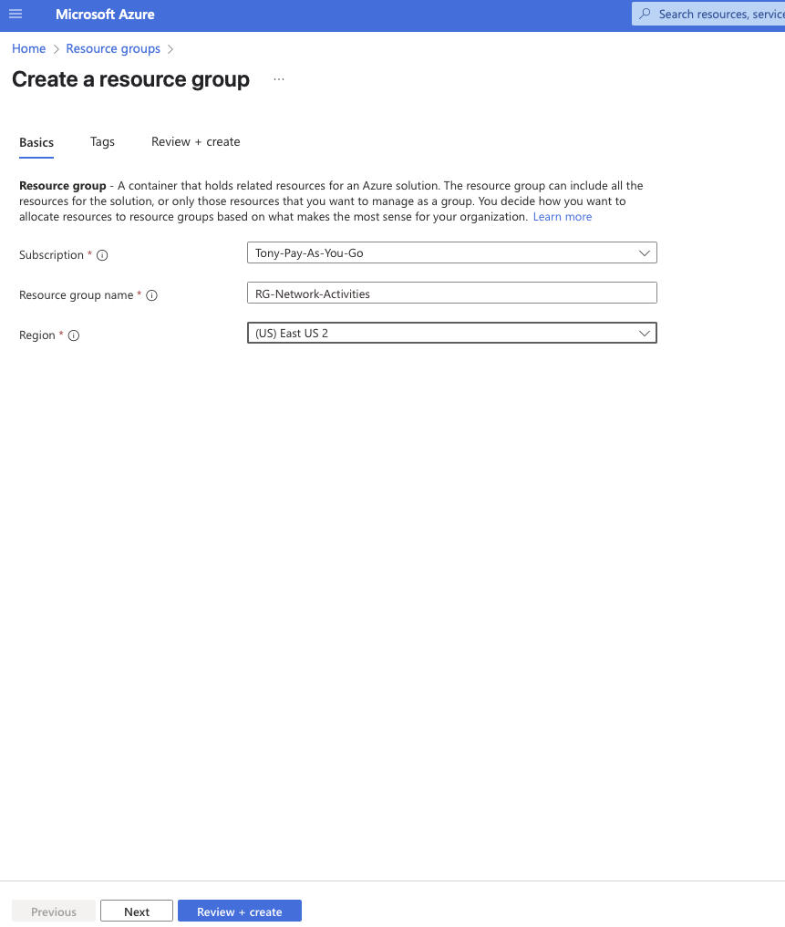

## Create a Windows Virtual Machine

1. Go to Virtual Machines
2. Click + Create → Azure virtual machine
3. Select the Resource Group RG-Network-Activities

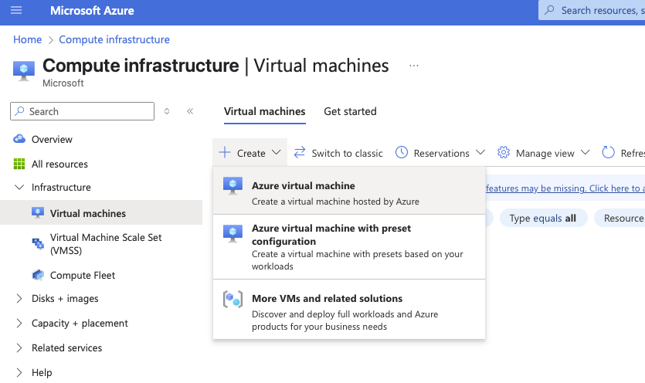

## Configure the Windows VM

Basic Tab Setup:

* VM Name: windows-vm (any name that you want).
* Region: East US 2 (same region as the Resource Group for purposes of this exercise)
* Availability Zone: Zone 1
* Image: Windows 11 Pro, version 24H2 - x64 Gen2
* Size: Standard_D2s_v3
* Security Type: Trusted launch virtual machines
* Username: labuser
* Password: Your secure password
* Public inbound ports: Allow RDP (3389)
* Be sure to click the confirm that you have eligible Windows 10/11 license with multi-tenant hosting rights at the bottom of the screen
* Disk, Networking, Management, Monitoring, Advanced & Tags (for purposes of this exercise we’ll skip these steps, we don’t need to change or add anything here)
* Click Review & Create and start the deployment process
* After clicking review and create and after the Validation Test has passed

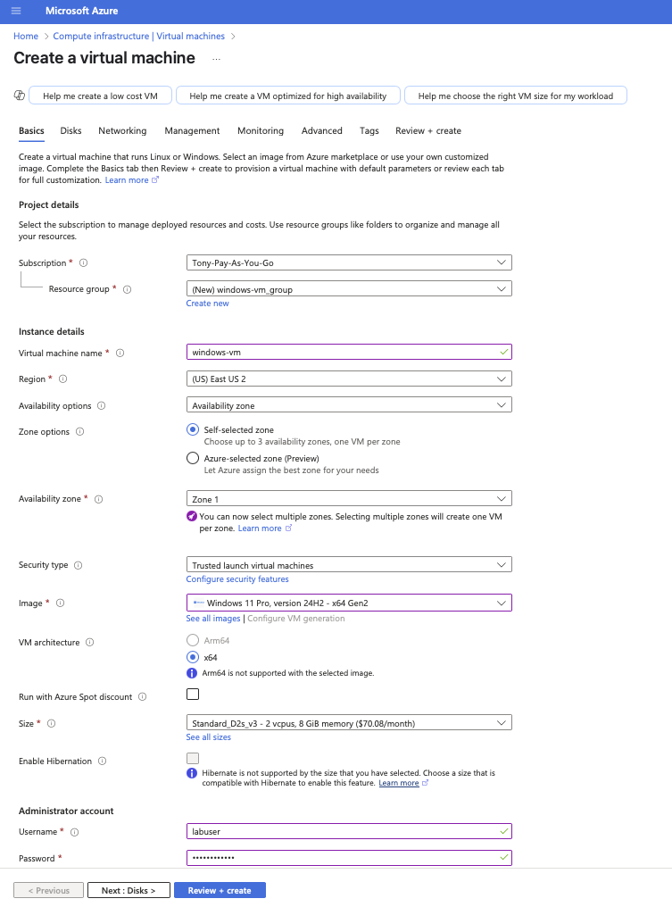

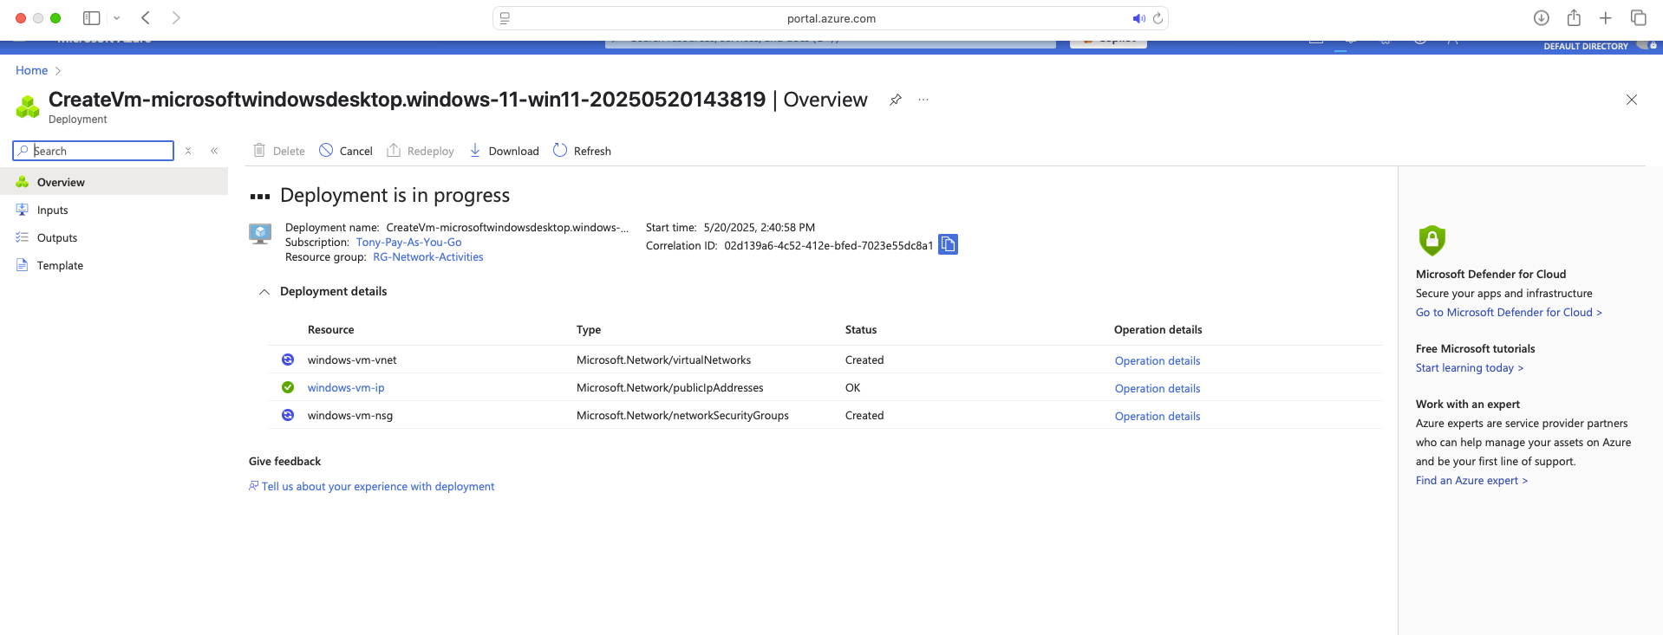

## Deployment Configuration Completion

* It is good practice to go back to the Virtual Machines and double check the VM is running

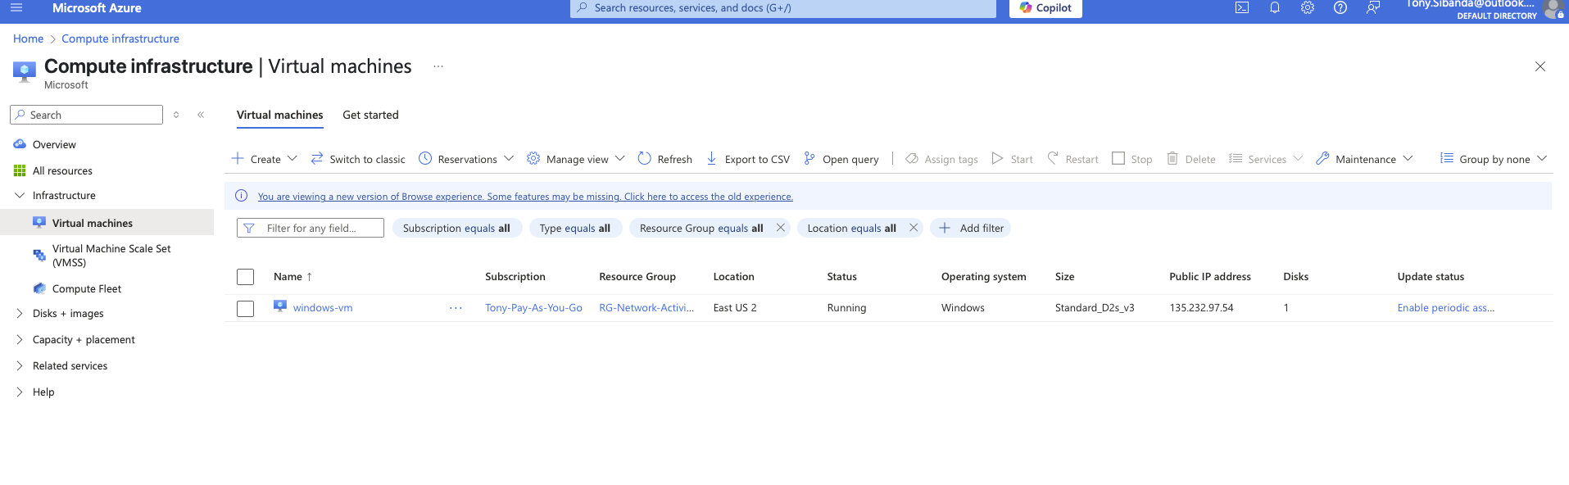

## Create a Linux Virtual Machine

1. Go to Virtual Machines
2. Click + Create → Azure virtual machine
3. Select the Resource Group RG-Network-Activities

**

Basic Tab Setup:

* VM Name: linux-vm
* Image: Ubuntu Server 22.04 or 24.04 LTS
* Authentication Type: Password
* Username: labuser
* Password: Your secure password
* Public inbound ports: Allow SSH (22)
* Keep the other settings consistent with the Windows VM

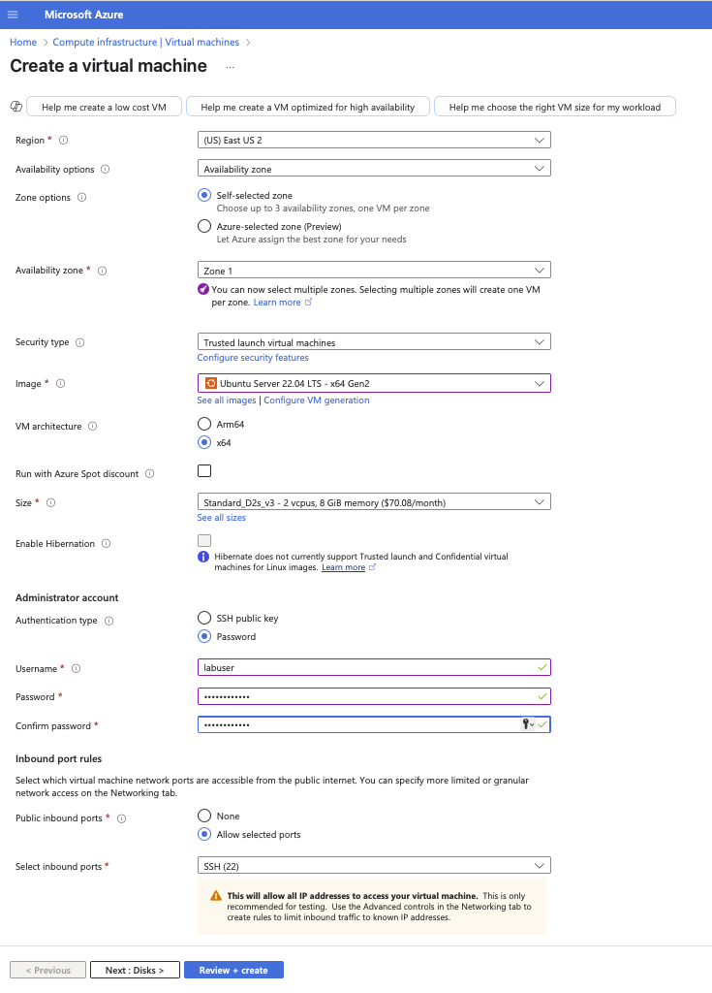

## 

## Configure Disks

* Disk Type: Premium SSD
* Leave default size and redundancy (locally-redundant)
* Check the option to Delete disk when VM is deleted

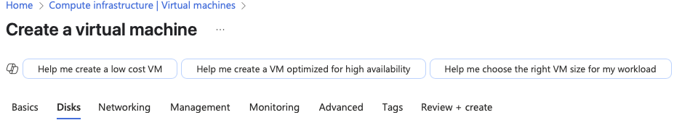

Configure Networking

* Virtual Network: We’ll use the windows-vm network that we just created
* Public IP: Automatically assigned
* NIC Security Group: Basic
* Public inbound ports:
  + Windows VM: RDP (3389)
  + Linux VM: SSH (22)
* Leave Accelerated Networking enabled

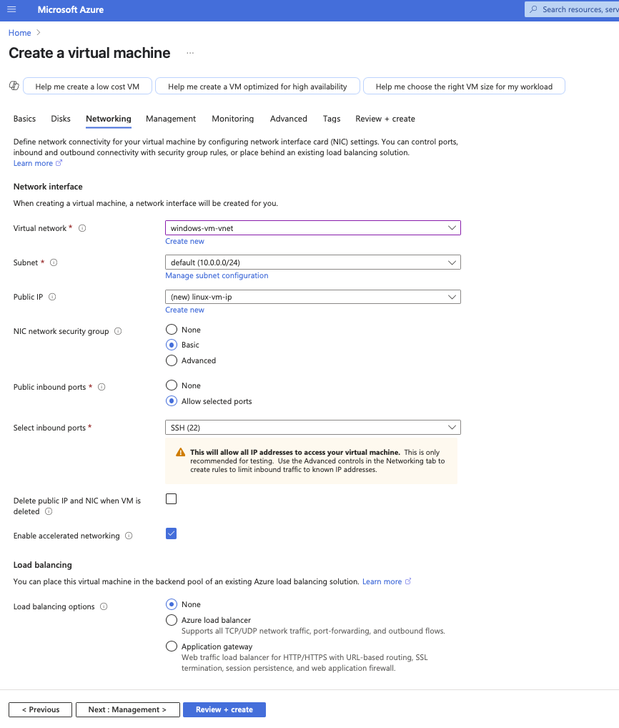

Why We Skip the Remaining Tabs (Management, Monitoring, Advanced, Tags)

These tabs are optional and not necessary for basic setups or practice labs:

* Management: Enables auto-shutdown, backup, and diagnostics, useful later but not needed for testing.
* Monitoring: You can configure insights and metrics later if desired.
* Advanced: Not required unless you need VM extensions or custom scripts.
* Tags: Useful in enterprise environments for cost tracking, optional for personal use.

## Review and Create

* Azure runs a validation check.
* If successful, click Create to begin deployment.

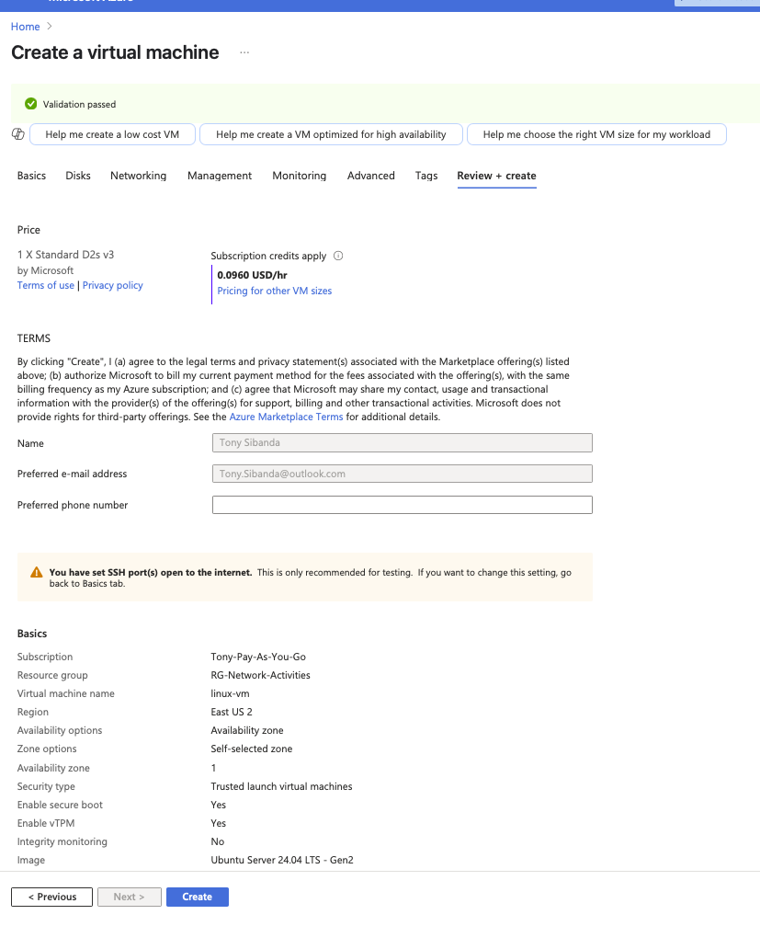

## Deployment Progress

Azure will begin provisioning resources:

* Virtual Network
* Subnet
* NSG (Network Security Group)
* Public IP
* Disk and NIC

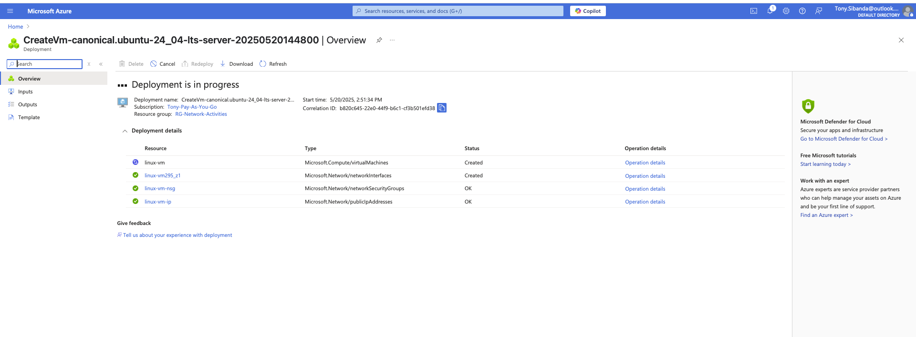

## Deployment Complete

After a few minutes, you’ll see Deployment Succeeded.  
Click Go to resource to view your new virtual machine.

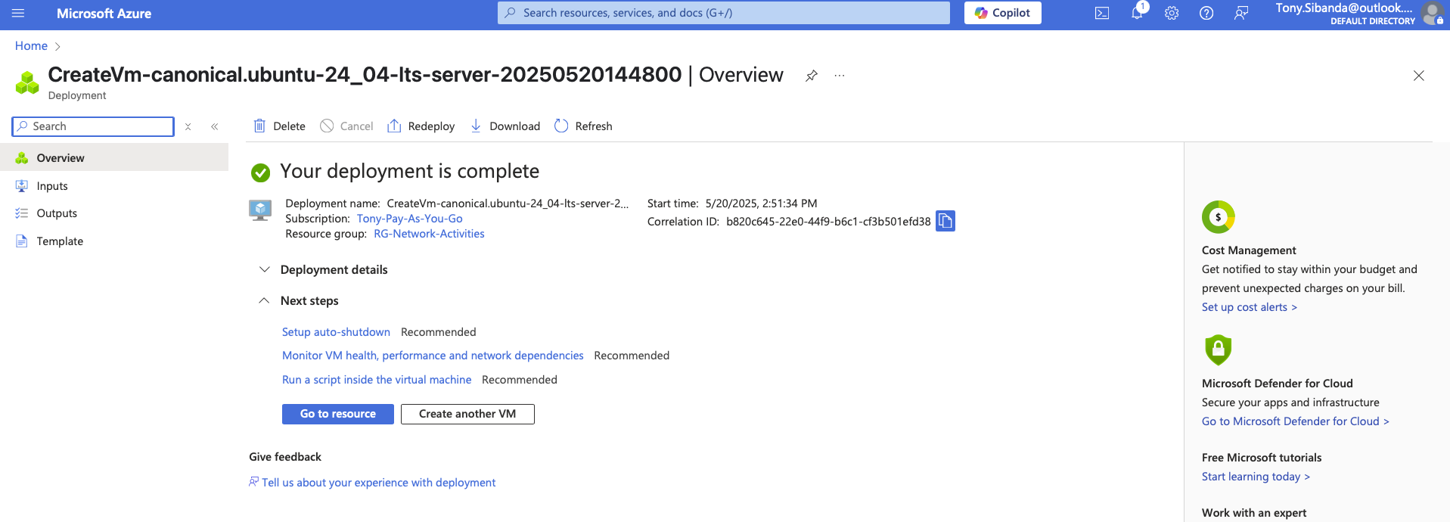

## 

## Verify Virtual Machines

Go back to the Virtual Machines panel.  
Confirm both windows-vm and linux-vm show status as Running and have public IP addresses assigned.

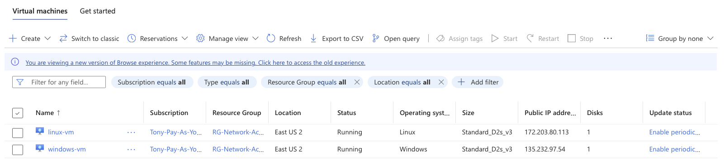

## Best Practices

* Shutdown unused VMs to avoid charges
* Use NSG rules to secure access (don’t allow all IPs in production)
* Consider Azure Bastion or VPN for secure remote access
* Use Tags when working with multiple environments or users